Form view event handling –

(Similar to repeater, data list concept)

Form view editor is work on row format

Find any type of control inside the form view using FormViewRow objects

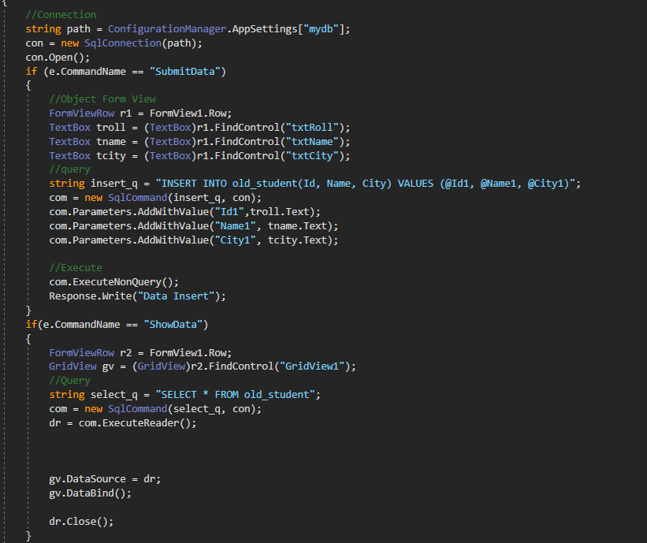

Assignment update delete

Store procedure connectivity inside aspx page?

Step

1. Include library (System.Data)
2. In store procedure is use to command type property.
3. In store procedure concept SQLCommand objects is used to specific parameter.
4. Sql(“procedureName”, connection object)
5. SqlCommand(“proname”,con)

Assignment –

Perform all operation using store procedure.

